

Sri Lanka Institute of Information Technology

B.Sc. Honors Degree in Information Technology

Specialized in Software Engineering

Final Examination

Year 3, Semester 1 (2021)

SE3040 – Application Frameworks

Group Project

User Guide

Group ID: 2021S1_REG_WD_02

Group Name: 2021S1_REG_WD_02

|  |  |
| --- | --- |
| Student ID | Student Name |
| IT19018256 | Irfan S.M.M |
| IT19134468 | Sithpavan. G |
| IT19156170 | Kajathees. P |
| IT17016476 | R. Danuzon |

Contents

1. User (IT19156170 – Kajathees.P)
   1. User registration page
   2. User login page
   3. Research submission page
   4. Research submission by user page
   5. Workshop details submission page
   6. Workshop details submission by user page
   7. Payment gateway page
   8. Attendee payment page
2. Reviewer (IT19134468 – Sithpavan. G)
   1. Homepage of the reviewer dashboard
   2. List of the research paper submissions page
   3. Research paper review page
   4. List of the workshop details submissions page
   5. Workshop details review page
3. Editor (IT19018256 – Irfan S.M.M)
   1. List of conference details page
   2. Create conference details page
   3. Edit Conference page
   4. List of speaker
   5. Create speaker List
   6. Edit speaker List
4. Admin (IT17016476 – R.Danuzon)
   1. Dashboard of the admin
   2. List of the conference details page
   3. List of the user details page
   4. List of the staff details page
   5. Create staff details page

* **User**
  + **User registration page**

User can register themselves to the system by filling the required fields.

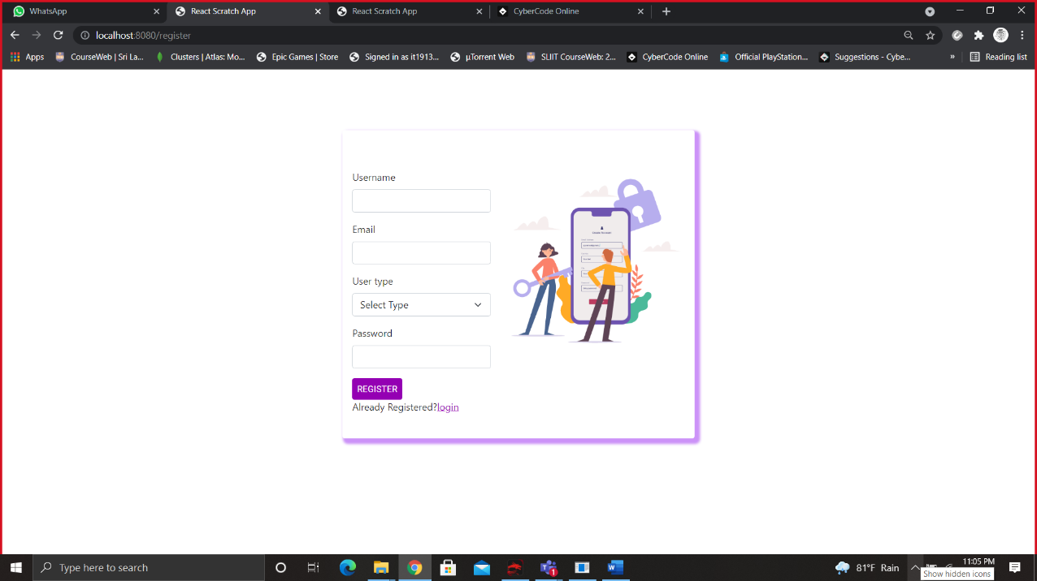

In the registration page, user can select what type of user they are registering as.

* + **User login page**

User can access login into the system by using this page.

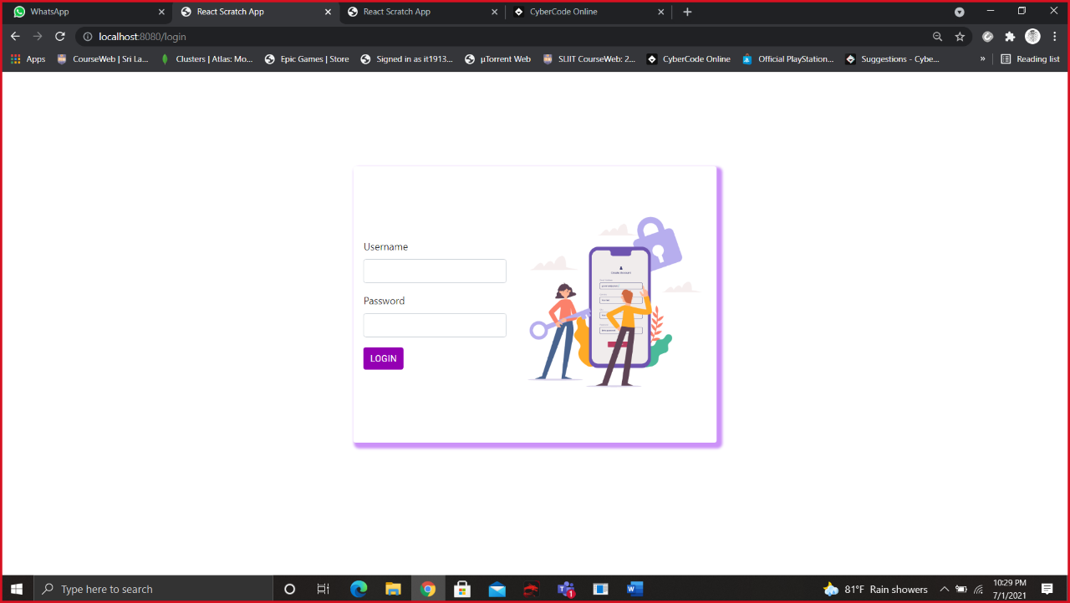

Entering the valid credentials will allow the users to access the restricted functionalities in the web applications.

* + **Research submission page**

If the user is a researcher, he/she can submit the pdf document of their research for the reviewer to review. Researcher can enter the details of document and can upload the document using this page. The researcher can click the download button to get the template for the research paper.

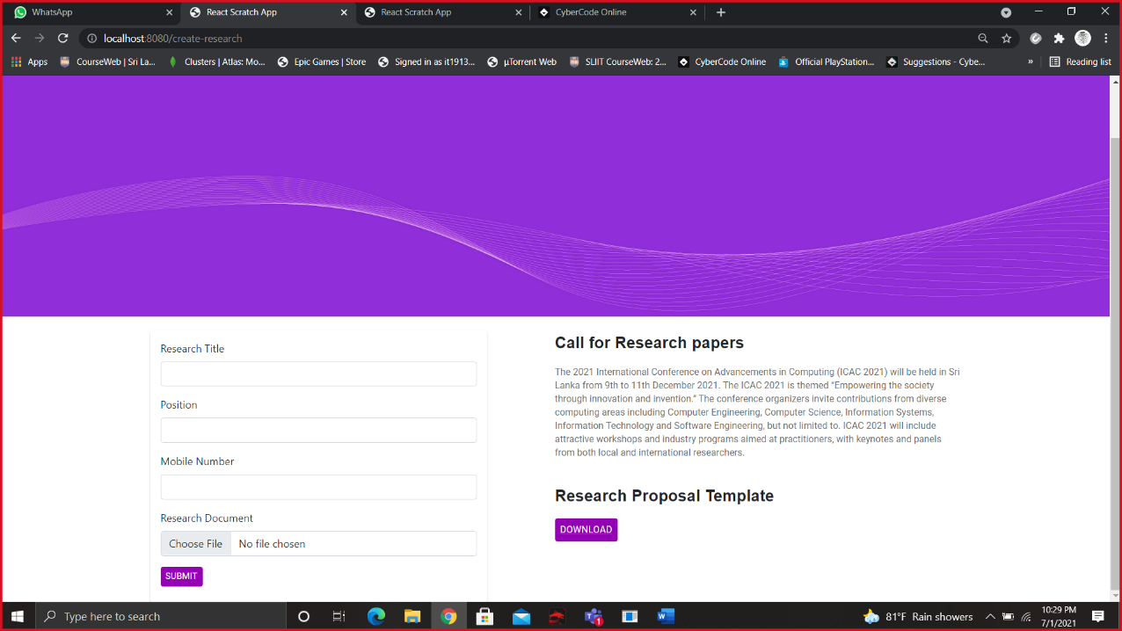

* + **Research submission by user page**

Researcher can view the submissions they made in this page. They can also view the status of their submission regarding the document. Once, reviewer approves a document, the status will change into Approved and will give the option to pay for the conference. Or if the reviewer declines the document, the status will change into Declined.

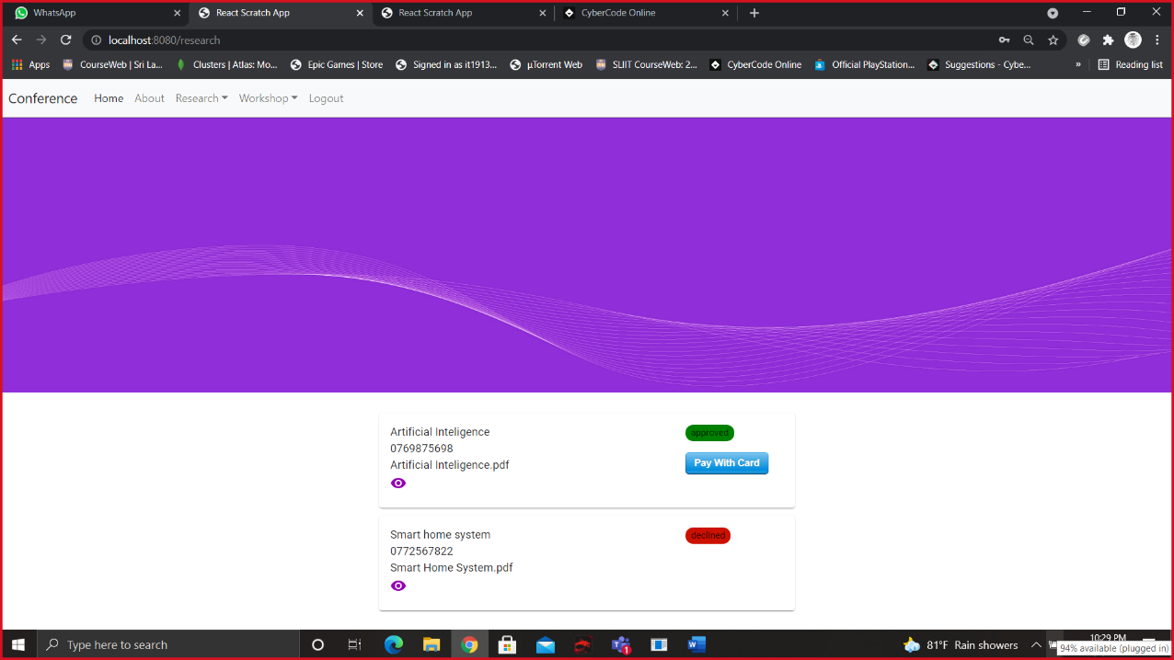

The researcher can also view their submissions by clicking the view icon.

* + **Workshop details submission page**

If the user is a workshop conductor, he/she can submit the ppt document of their research for the reviewer to review. Workshop conductor can enter the details of document and can upload the document using this page. The workshop conductor can click the download button to get the template for the workshop details.

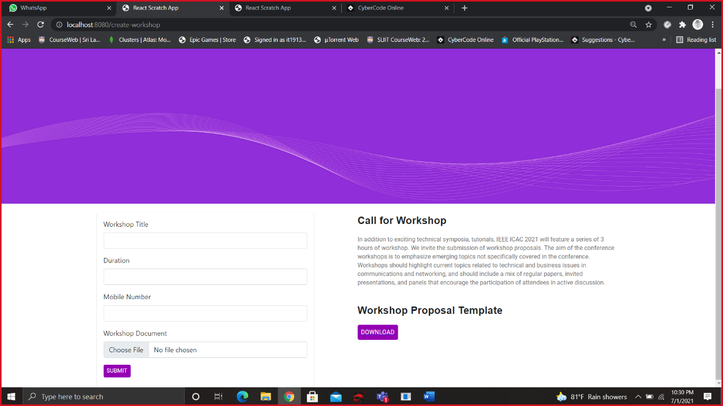

* + **Workshop details submission by user page**

Workshop conductor can view the submissions they made in this page. They can also view the status of their submission regarding the document. Once, reviewer approves a document, the status will change into Approved. Or if the reviewer declines the document, the status will change into Declined.

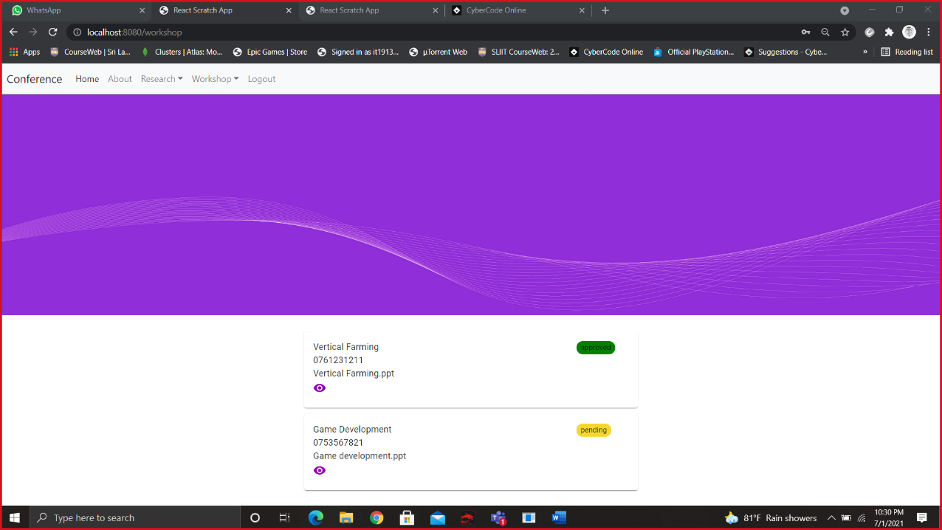

The workshop conductor can also view their submissions by clicking the view icon.

* + **Payment gateway page**

Once the research paper gets approved, a pay with card button will appear to the researcher. Once he/she clicks, it will get them to this page, where they can pay for the conference.

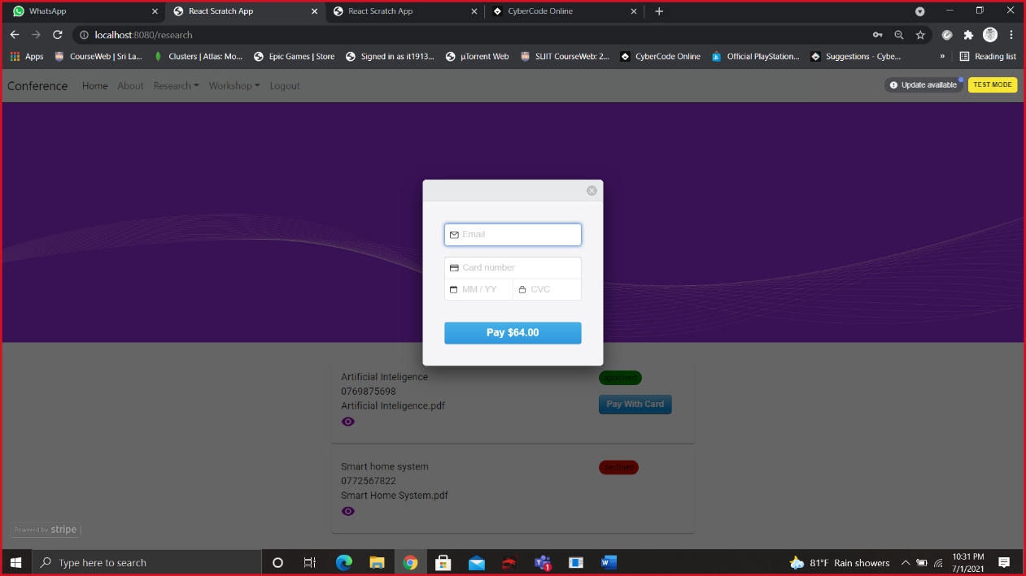

* + **Attendee payment page**

This page provides a way to pay for conference. Once the user registers as an attendee he/she will be redirected to this page, to do the payment. By clicking the ‘Pay with card’ button, the user will be redirected to the payment gateway to complete the payment.

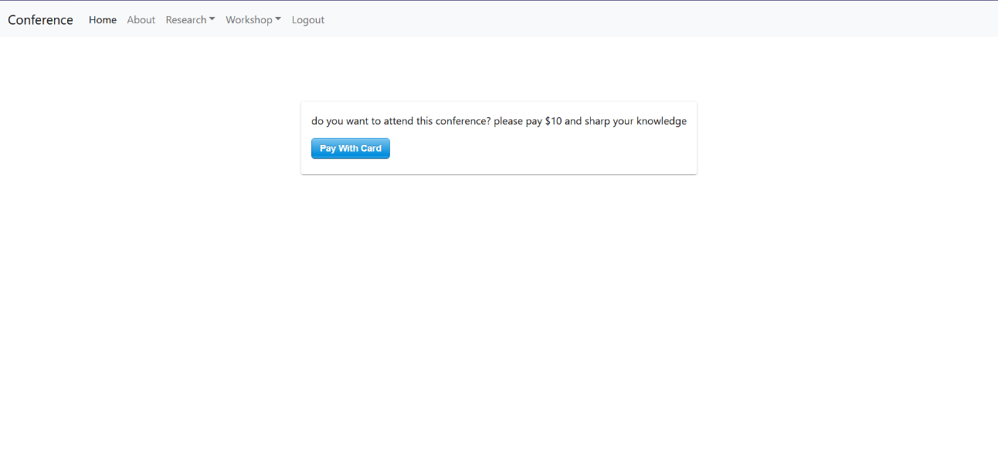

* **Reviewer**
  + **Homepage of the reviewer dashboard**

Reviewer can access their functionalities from the reviewer dashboard.

On the top part of the user interface, there is a navigation bar for the reviewer to navigate through the pages of the reviewer dashboard. On the homepage of the dashboard features the live count of the submissions in the database to get a quick summary.

* + **List of the research paper submission page**

This page features the list of research paper submission for the reviewer to view. By clicking the review submission button. The web application will redirect the reviewer to the Research paper review page for the research to view the submitted documents and update its status.

* + **Research Paper Review page**

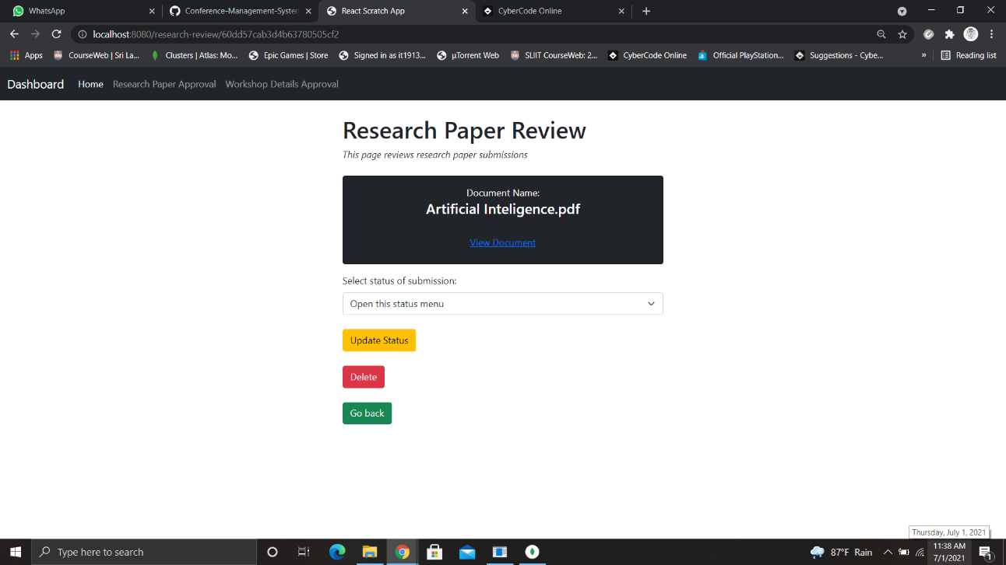

This page retrieves the particular document which the reviewer clicked in the previous page to review. The reviewer can view the research paper by clicking the ‘View Document’ link. They can also download it. After the document is reviewed, the reviewer can update the status by clicking the drop-down menu and select the status option. (ex: Approved, Declined).

The reviewer also has the option to delete the submissions.

The ‘Go Back’ will redirect the reviewer to the research paper list page.

* + **List of the workshop details submission page**

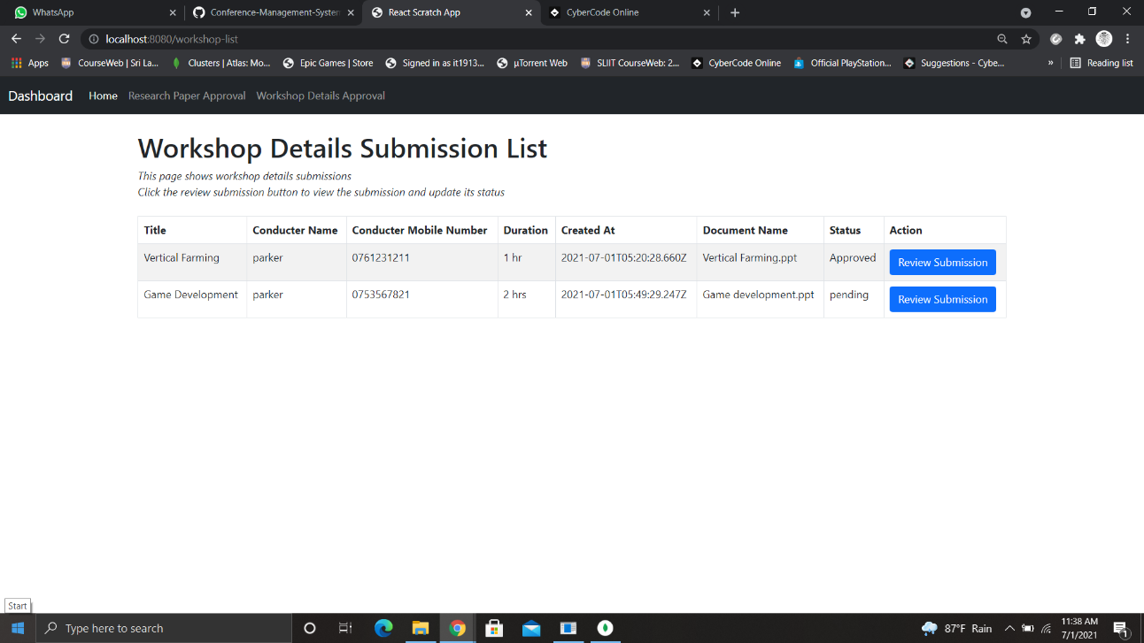

This page features the list of workshop details submission for the reviewer to view. By clicking the review submission button. The web application will redirect the reviewer to the Workshop Details review page for the research to view the submitted documents and update its status.

* + **Workshop details Review page**

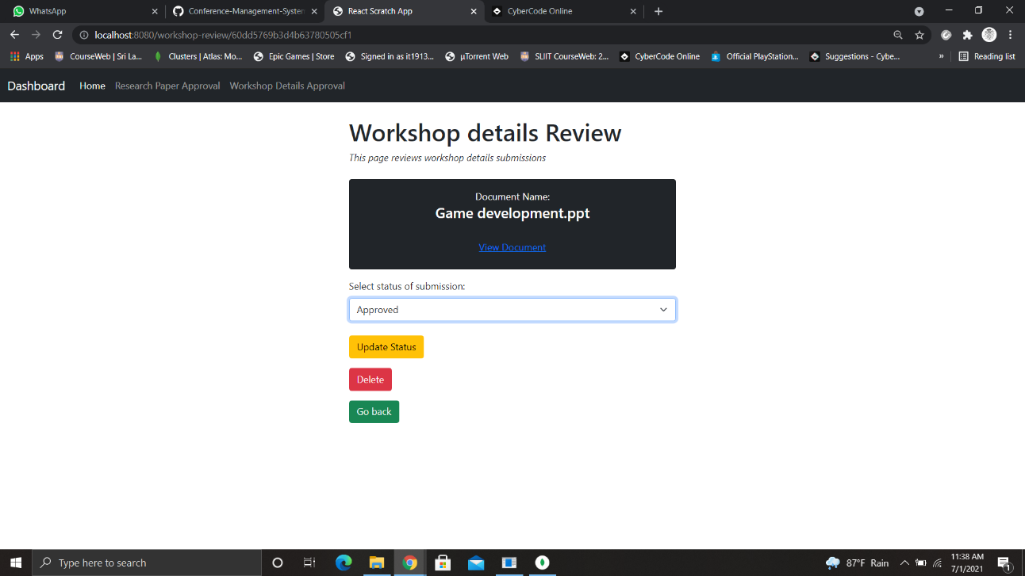

This page retrieves the particular document which the reviewer clicked in the previous page to review. The reviewer can view the workshop details by clicking the ‘View Document’ link. They can also download it. After the document is reviewed, the reviewer can update the status by clicking the drop-down menu and select the status option. (ex: Approved, Declined).

The reviewer also has the option to delete the submissions.

The ‘Go Back’ will redirect the reviewer to the research paper list page.

* **Editor**
  + **List of conference details page**

Editor can see all the conference details on this page.

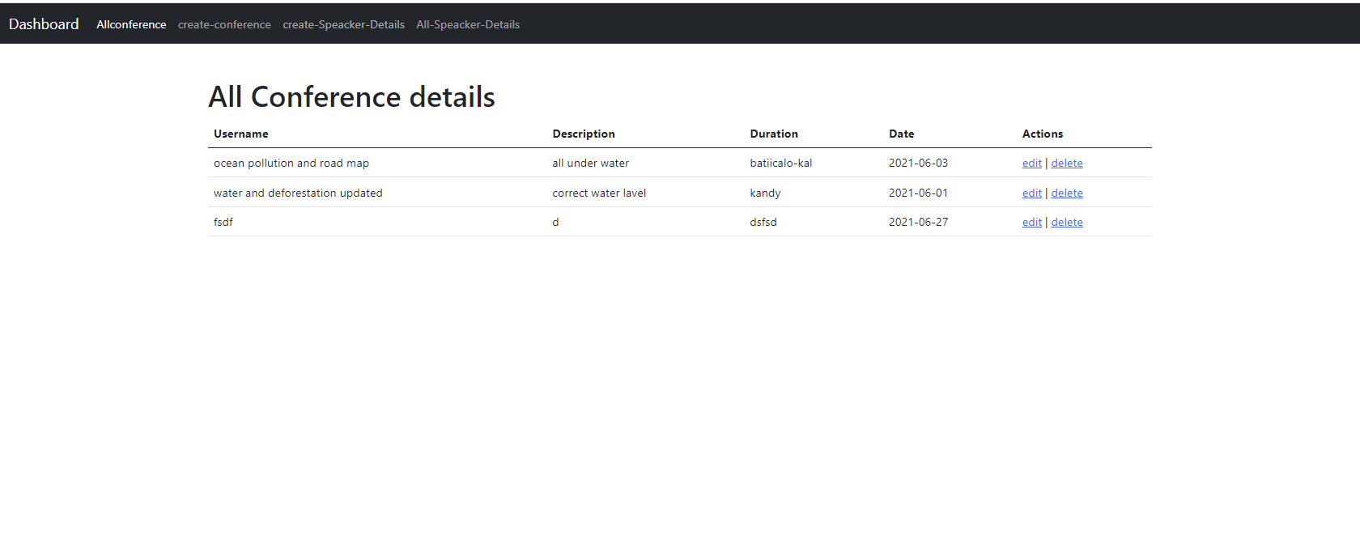

On the top part of the user interface, there is a navigation bar for the Editor to navigate through the pages of the Editor related details. Every conference details can visible on this conference details page. By clicking the “edit button” page will be redirect to the edit conference page. By clicking the” delete button” conference data will be delete from the database.

* + **Create conference details page**

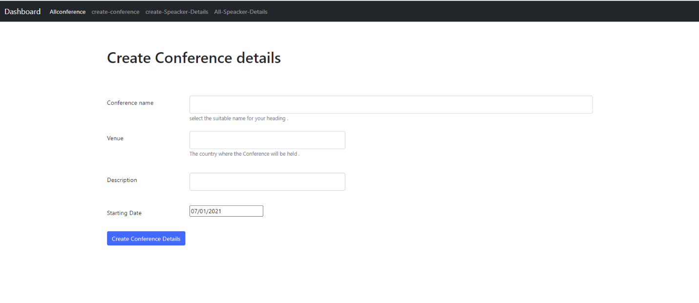

This page used to create conference details. Editor should provide all conference details according to the given input form. After that by clicking the “create submission details”. The web application will redirect the all-conference page to view the conference which is created.

* + **Edit conference page**

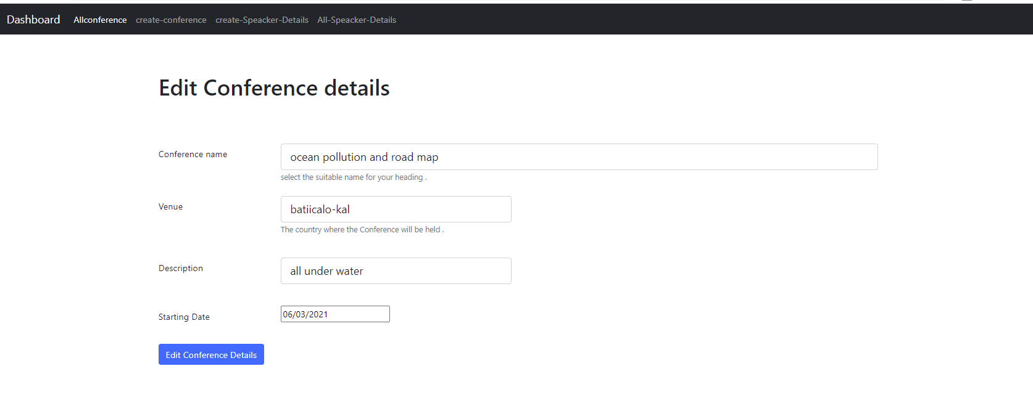

This page used to edit the conference details. Editor should provide the data which need to edit by editor after that by clicking the “Edit submission details”. The web application will redirect the all-conference page to view the conference which is created.

* + **List of speaker**

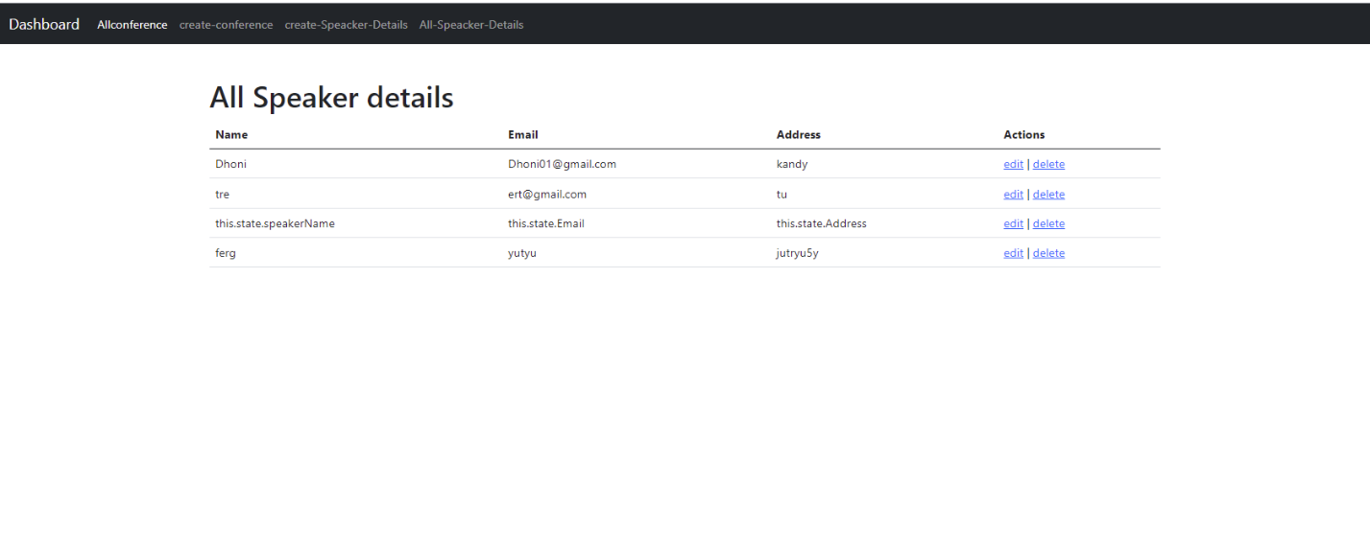

This page features the list of speaker details from the database to retrieve the editor. By clicking the “edit button” page will be redirect to the edit conference page. By clicking the” delete button” conference data will be delete from the database.

* + **Create speaker List**

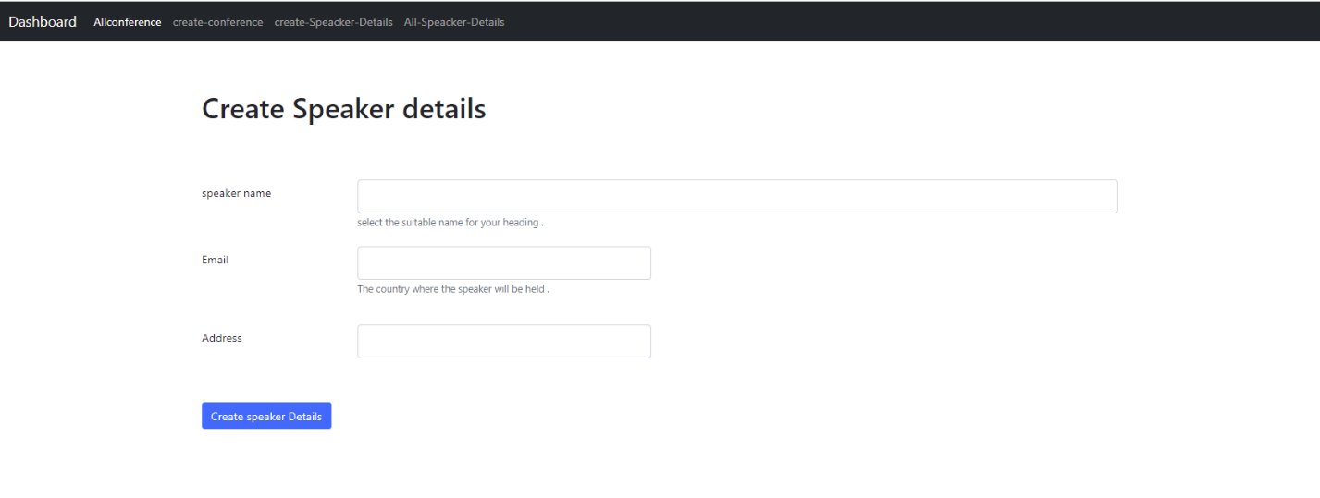

This page used to create speaker details. Editor should provide all speaker details according to the given input form. After that by clicking the “create speaker details”. The web application will redirect the all-conference page to view the conference which is created.

* + **Edit speaker List**

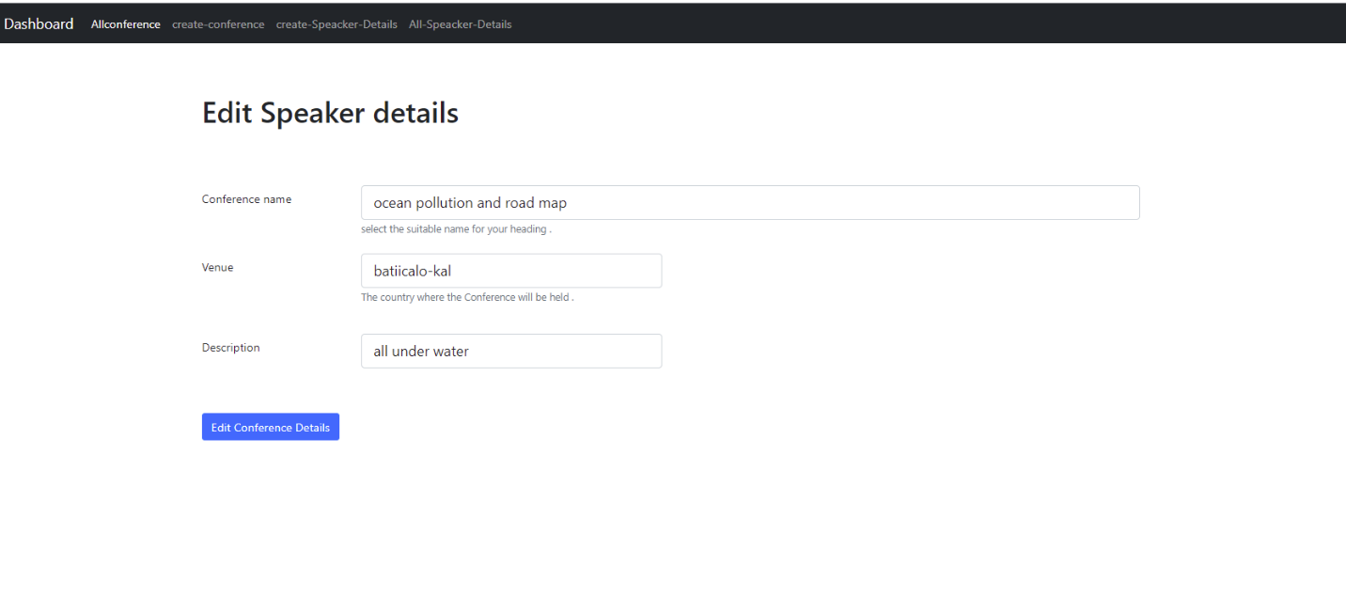

This page used to edit the speaker details. Editor should provide the data which need to edit by editor after that by clicking the “Edit submission details”. The web application will redirect the all-speaker page to view the conference which is created.

* **Admin**
  + **Dashboard of the admin**

Admin can access their functionalities from the admin dashboard.

On the top part of the user interface, there is a navigation bar for the admin to navigate through the pages of the admin dashboard.

* + **List of the conference details page**

This page features the list of conference details for the admin to view.

* + **List of the user details page**

This page features the list of user details for the admin to view.

* + **List of the staff details page**

This page features the list of staff details for the admin to view.

* + **Create staff details page**

This page features to create staff details.